Our Great Ocean Road

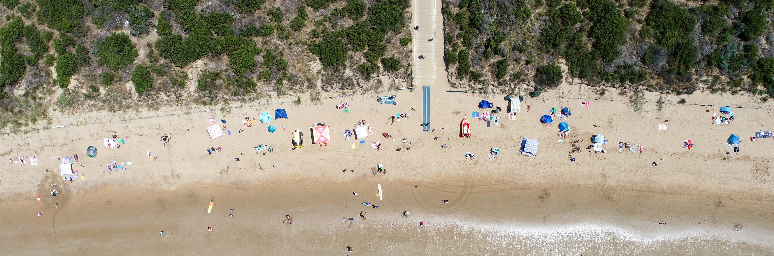

A SUMMER WELL SPENT: THANKS TO OUR VOLUNTEERS

# As summer officially begins to wind down, many of us are back at work, packing up the



**Continue the story.**

[**www.greatoceanroadauthority.vic.gov.au**](http://www.greatoceanroadauthority.vic.gov.au/)

**campsite, or shaking off the last grains of sand before settling into the rhythm of the year ahead.**

It’s been another spectacular season along the Great Ocean Road - our beaches and parks alive with happy faces, making lifelong memories under the summer sun.

But before we move forward, we want to take a moment to recognise the unsung heroes of our region - the volunteers who

give their time, skills, and passion to keep our beautiful coast and parks safe and thriving.

Whether you’ve just visited for a day or called this place home

for years, chances are, their hard work has shaped your experience.

## THE POWER OF VOLUNTEERING

Every corner of the Great Ocean Road has a story, and more often than not, it’s a volunteer who is helping to write it.

Over the past year, more than 500 community volunteers have worked directly with

us, contributing more than 6000 hours of their time – an extraordinary contribution.

Take the BirdLife volunteers, for example. More than 50 dedicated individuals have spent over 3,000 hours monitoring and protecting the endangered Hooded Plover.

These tiny shorebirds, affectionately known as “Hoodies”, face immense challenges, with their nests vulnerable to tides, predators, and human activity.

Thanks to the tireless work of these volunteers who educate visitors, stand post at protective zones, and monitor breeding pairs - our Hoodies have a fighting chance.

Corporate groups are also rolling up their sleeves. Rip Curl’s Planet

Day saw 86 staff dedicate 600 hours to conservation work, showing that protecting this region is a responsibility we can all share. From cleaning up beaches to restoring fragile ecosystems, their hands-on efforts make a tangible difference.

And the list doesn’t stop there. Across the region, groups like the Torquay, Aireys Inlet, and Anglesea Rubbish Rangers, Biolinks Port Campbell, the Southern Otway Landcare Network, LorneCare, and the Apollo Bay Landcare Group - just

to name a few - commit countless hours to preserving our coastal landscapes. Whether removing invasive weeds, planting native vegetation, or maintaining walking trails, their work ensures that these spaces remain pristine for generations to come.

## A COMMUNITY EFFORT

One of the most remarkable things about volunteering is the collective impact it has. It’s not simply about the hours donated, it’s about the knowledge shared, the connections built, and the passion that fuels every project.

Our citizen scientists, for instance, play a crucial role in conservation.

A great example are EstuaryWatch volunteers, who collect data monthly on the condition of estuaries along the Great Ocean Road. This data collection has created quality, long-term data records are used in the direct management of the estuaries, informing estuary management plans, incident response and research projects.

Without them, our understanding of the region’s changing environment would be far less detailed.

Then there are the local community members who serve as the eyes and ears of the region, noticing when a track needs maintenance, when a new species

appears, or when an area needs attention. Their deep connection to the coast and parks provides invaluable insight that helps guide our work and perform more effectively.

There isn’t enough space to name every group that contributes—but that, in itself, is a testament to

the strength of our community. Like the CFA and SES teams who are there in times of crisis to the volunteers who keep our sporting clubs running, these individuals form the backbone of our region.

And, of course, our volunteer surf lifesavers, standing watch along the coast, ensuring everyone’s safety. Surf lifesaving clubs are the backbone of coastal safety, providing essential rescue services, first aid, and public education to keep beachgoers safe. Run largely by dedicated volunteers, these clubs foster community spirit, train the next generation of lifesavers, and play a crucial role in community safety along our coastline.

Many things are indeed great about our region, but most of all, it’s the people.

The truth is, government agencies and conservation groups can’t, and shouldn’t, do it all alone.

A place as vast and diverse as the Great Ocean Road needs a network of stewards, and we are

so fortunate to have a community that takes this responsibility to heart.

## WHY IT MATTERS

It’s easy to think of the Great Ocean Road as just a scenic drive—one of Australia’s most iconic landscapes, with stunning beaches, towering cliffs, and lush rainforests. But beyond

the postcards and Instagram photos, it’s a living, breathing ecosystem that requires care and stewardship.

Without the help of volunteers, invasive species would spread

unchecked, fragile dune systems would erode, and native wildlife would struggle to survive.

The beaches and parks we all love might not be as clean, as accessible, or as vibrant as they are today.

Their work ensures that future generations, our children, grandchildren, and visitors yet to come will be able to experience the same breathtaking landscapes we enjoy now.

Every time someone walks along a well-maintained track, spots a Hoodie chick surviving against the odds, or enjoys a pristine litter- free beach and swims between the flags, it’s thanks in large part to the people who have quietly and selflessly given their time to care for this special place.

## A SIMPLE THANK YOU

A “thank you” never quite feels like enough for the incredible work our volunteers do, but it’s important to say it nonetheless. To each and every one of you who has given your time, energy, and expertise to keep this region safe and thriving - thank you.

Your efforts make our coast healthier, our communities stronger, and our summers that much more special.

As we look ahead to the rest of the year, let’s take a moment to appreciate all that has been done, and all that will continue to be done, to keep the Great Ocean Road coast and parks as

breathtaking, wild, and welcoming as ever.

Here’s to you, and here’s to many more golden summers ahead.

# Jodie Sizer

CEO